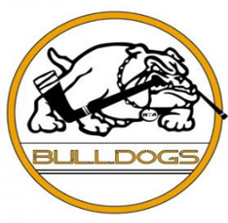 **Bulldogs Uniform Standards**

**2025-2026**

Game Jersey, Socks, and Shells must

Fit properly.

Be in neat and clean fashion

No tears, rips or stains

Practice Uniform:

Reversible Bulldogs Practice Jersey

Solid Bulldogs Blue Practice Socks

Helmet

To be White in color

Bulldogs Helmet stickers in correct locations

(Numbers on front and back BD logos on the sides)

Gloves

Glove colors should either be Navy, Navy and White, Navy and Yellow

Neck Guards

Are Mandatory at all Practices and Games; we follow USA Hockey.

Mouth Guards

12U and above Teams Required for all practices and games, as required by USA Hockey.

8U, 10U Teams Highly Recommended by USA Hockey

Bags:

All Players must use a Bulldogs Bag. If you have a Bulldogs Bag bag from a previous year you may continue to use it. If the bag needs replacing you must purchase a Bulldogs bag.

*Goalies may use a wheeled bag, without any team logo

Game Day Arrival clothes:

Players should arrive to games in Bulldogs attire as required by each team and have correct closed toed Athletic Shoes for Dryland. (No Crocs, or similar)

Player Initials ____________ Player #____________ Player Team _________________